
A 10
SET NO : 1

Sreenidhi Institute of Science & Technology
(An Autonomous Institution)
Code No: 101MA01

B. TECH. I – Year I – Semester Examinations, February, 2011 (Regular)
ENGINEERING MATHEMATICS – 1 (Common to EEE, ECE & ECM)

Time: 3 Hours Max. Marks: 70

Note: No additional answer sheets will be provided.

Part-A (Objective Type)
Max.Marks:20

Answer all QUESTIONS.

- Find the value of k when the inverse of 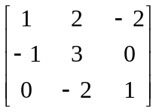 is 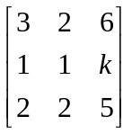

- Find the characteristic values of the matrix 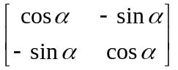

- Discuss the nature of the quadratic form without transforming to canonical form 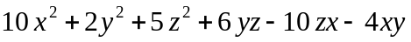

- Test the convergence of the series 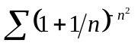

- Verify Rolle’s theorem for the function 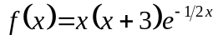 in (-3, 0)

- Verify the continuity of the function 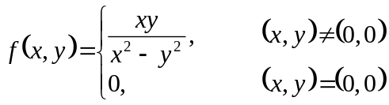

- Discuss the maximum and minimum of the function 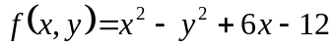

- Find the radius of the curvature of the curve 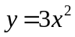at (1, 3)

- Find the asymptotes of the curve 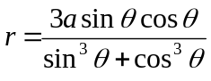

- Evaluate by changing the order of the integration 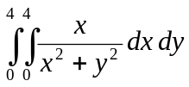

Part – B
Max. Marks: 50
ANSWER ANY FIVE QUESTIONS.
EACH QUESTION CARRIES 10 MARKS.

- a) Show that the system
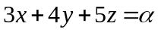
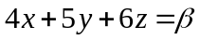
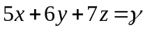
is consistent only when α, β and γ are in A.P. (5)
- Find the rank of the matrix by converting the following matrix 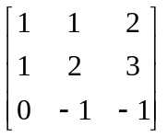 into normal form.
(5)

- a) Determine the characteristic roots and vectors of 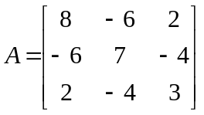 (6)
- If 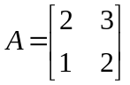, express A⁴ in powers of A. (4)

  - Reduce the quadratic form 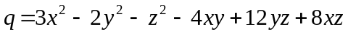 to canonical form by orthogonal reduction and find the corresponding transformation. (10)

  - a) Test the convergence of the series 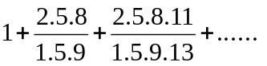 (5)
- Test the series for absolute/conditional convergence 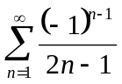 (5)

  - a) If 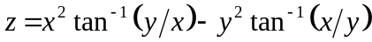, then find the value of 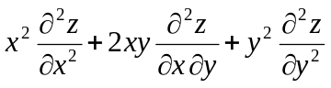
(5)
- If x = uv, y = u/v, then prove that 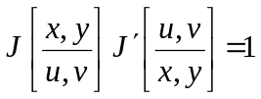 (5)

  - a) Show that the radius of curvature of at P on the ellipse 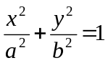is CD³/ab where CD is the semi diameter conjugate to CP. (5)
- Show that the evaluate of the curve 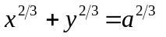is 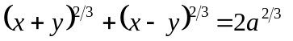(5)

  - a) Trace the curve 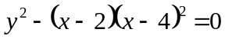 (5)
- Trace the curve given by 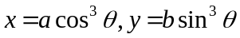 (5)

  - a) Find the total length of the curve 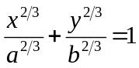 (5)
- Evaluate 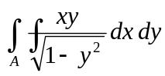, where A is the area in the positive quadrant of the circle 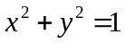 (5)

- 0 - 0 -

